|  |
| --- |
| Functional test cases -  Invalidation |
| DMS H7 |

|  |
| --- |
| Test Scenarios – Invalidation  May 2021 |
|  |

# Document version

|  |
| --- |
|  |
| Document version:   |  |  |  |  | | --- | --- | --- | --- | | Version nr. | Dato | Created by | Updates | | 1.0 | 11-05-2021 | Emma Hagerup |  | |

Table of Content

1 Document version 1

2 Introduction 3

2.1 Test data and preconditions 3

2.2 Process flow 3

2.3 Test Scenarios 4

3 Detailed test scenarios 5

3.1 Scenario 1: Invalidation application rejected based on format validation 5

3.2 Scenario 2: Invalidation application with notification on decision of manual handling 5

3.3 Scenario 3: Invalidation application with notification of granted application 6

# Introduction

The purpose of this test is to ensure that the economic operator (EO) can apply for an   
invalidation of an already existing declaration. An invalidation application is sent by the EO to the DMS ERMIS system. A declarant can apply for an invalidation without economic   
consequences if they apply for invalidation before the goods are released. However, an   
invalidation application can also be applied for released and paid goods but here we refer to the   
“Invalidation and repayment” test case.

Further, an invalidation application can be rejected if the declarant does not provide or fulfill the requirements for documentation for the reason of the invalidation.

## Test data and preconditions

To be able to do the test scenarios the EO has to be able to send a H7 declaration to DMS, and therefore must have had completed test phase 1 being the connectivity test (See Connectivity Guide document).

The EO must therefore be able to send an invalidation application with the following services:

* DMS.Import.Declaration.Submit
* DMS.Import.Declaration.Invalidate

To endpoint:

* https://secureftpgatewaytest.skat.dk:6384/exchange/CVR_<CVR>_UID_<UID>

## Process flow

The process flow for applying for an invalidation of a declaration can be seen in Figure 1 below.

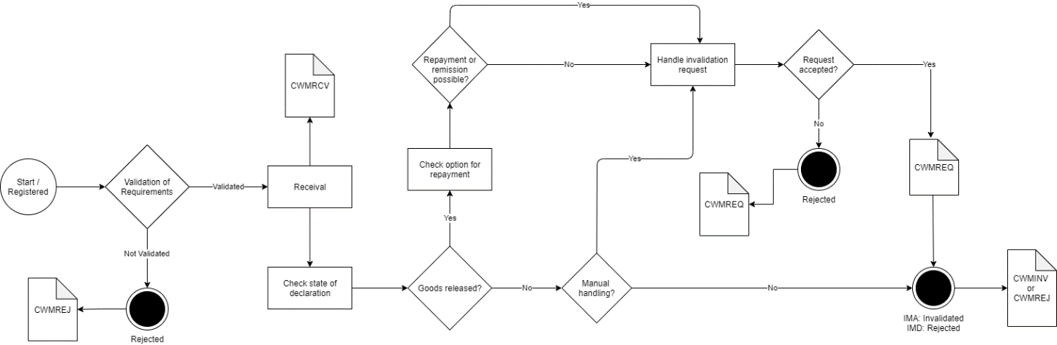

Figure 1

## Test Scenarios

To complete the functional onboarding phase two, the OE must deliver confirmation of passed test-cases for each test scenarios:

|  |  |  |
| --- | --- | --- |
| **Test no** | **Test Scenario** | **Passed** |
| **1** | Send invalidation application which is synchronously rejected based on format validation | ☐ |
| **2** | Send invalidation application and receive notification of decision on manual handling of invalidation application | ☐ |
| **3** | Send invalidation application and receive notification of granted invalidation application | ☐ |

Figure 2 shows the process flow divided into the above mentioned 4 scenarios.

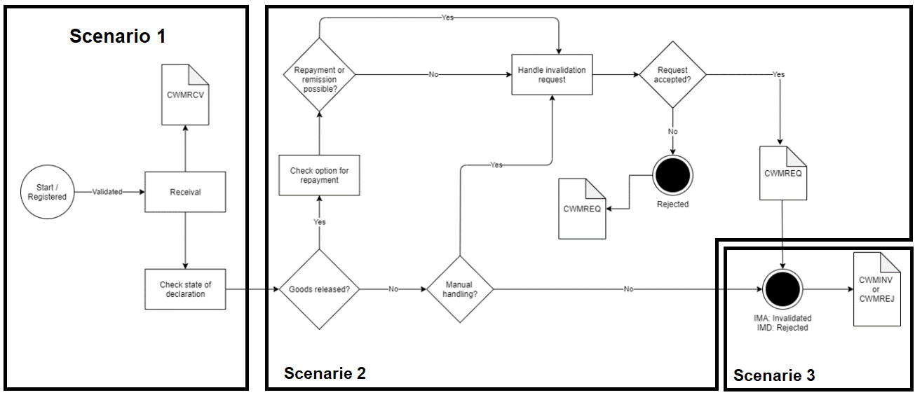

Figure 2

# Detailed test scenarios

The following sections will describe the aim of the specific test scenarios and it will provide the desired results of the test. It should be noted that there can be changes in the notifications provided by the DMS solution, because the solution is still in development. If at a later point more notifications will be added the EO will be informed about this and the EO will be requested to complete the test again.

## Scenario 1: Invalidation application rejected based on format validation

The following sections will describe the aim of the test and it will provide the relevant test data and results of the test.

The aim of scenario 1 is to test if the EO can send an application for invalidation and get a rejection. The rejection is based on a failed syntax validation, to trigger this an invalidation with an erroneous .xml is sent.

**Success**

For this test case to succeed, the invalidation application should be rejected based on a syntax error. The error will be sent in a synchronous response.

**Test data example**

The following test data should be used:

* Submit initial H7 declaration: *IMA.xml* (remember to fill in LRN)
* Test for wrong format sending invalidation application with wrong syntax in field FunctionCode:

<ns2:FunctionCode>H</ns2:FunctionCode>

* Fill in the syntax error XML: *Inv_scenario_1.xml* with preferred LRN and assigned MRN and submit the XML.

## Scenario 2: Invalidation application with notification on decision of manual handling

The following sections will describe the aim of the test and it will provide the relevant test data and results of the test.

The aim of scenario 2 is to test if the EO can obtain notification that the invalidation application has been chosen for manual handling. Note: there is a special ruleset for invalidation for PostNord.

**Success**

A notification has been successfully applied for and received.

**Test data example**

* Submit initial H7 declaration: *IMA.xml* (remember to fill in LRN)
* Fill in the invalidation XML: *Inv_scenario_2.xml* with preferred LRN and assigned MRN and submit the XML.
* Since the request is manually handled by a customs officer you should contact you assigned onboarding contact person when the request has been successfully sent:
  + Write an email to your onboarding contact person with the following information:
    - Which application was sent (in this case: an invalidation and repayment application)
    - MRN
    - LRN

Your onboarding contact person will then grant the invalidation and repayment application which fulfills Scenario 2.

* Pull notification to see notification of granted invalidation application.

## Scenario 3: Invalidation application with notification of granted application

The following sections will describe the aim of the test and it will provide the relevant test data and results of the test.

The aim of scenario 3 is to test that the EO can obtain notification that the original declaration can be invalidated.

For the test to succeed the EO should be able to receive notifications about acceptance of the invalidation application.

Test data example:

There is no test data for this scenario, after the invalidation application has been granted, the process of invalidating the declaration is making its way through the system, it should only take 5-10 minutes.

Do following steps:

* Wait 5-10 minutes for the invalidation process to go through the system.
* Pull notification to see notification of granted invalidation application.

#Decorative

|  |  |  |  |
| --- | --- | --- | --- |
|  | www.ufst.dk  ISBN |  | Udviklings- og Forenklings- styrelsen er en del af  Skatteforvaltningen |